**NANDHA ENGINEERING COLLEGE**

**(Autonomous Institution)**

Erode-638 052



**TABLEAU-TWO CREDIT COURSE**

**IV – Semester**

**B.Tech - Artificial Intelligence and Data Science**

**NAME : HARI RAM.S**

**BRANCH : B.TECH AI & DS**

**YEAR : II**

**WHAT IS TABLEAU ?**

* It's mainly used for **Business Intelligence (BI)**.
* It helps users **analyze**, **visualize**, and **share** data insights without needing deep programming knowledge.
* It connects to many types of data sources — Excel files, databases like SQL, cloud services like Google Sheets, and more.
* With Tableau, you can create **interactive dashboards** that allow users to explore the data themselves (for example, by clicking on a chart to drill down into more details).

**Advantages of Tableau**

1. User-Friendly Interface,
2. Handles Large Data Efficiently,
3. Real-Time Data Analysis,
4. Wide Variety of Visualizations,
5. Connects to Multiple Data Sources,
6. Interactive and Dynamic Dashboards,
7. Mobile Device Compatibility

**Spotify Listening History Analysis:**

This document presents an analysis of Spotify listening history using a Tableau dashboard. It explores key music features like acousticness, energy, danceability, tempo, and genre trends over time. The goal is to understand how musical styles and listener preferences have evolved from 1900 to 2020 through interactive visualizations.



**CHARTS IN THE DASHBOARD:**

**1.Yearly Trends of Acousticness, Energy, and Danceability:**

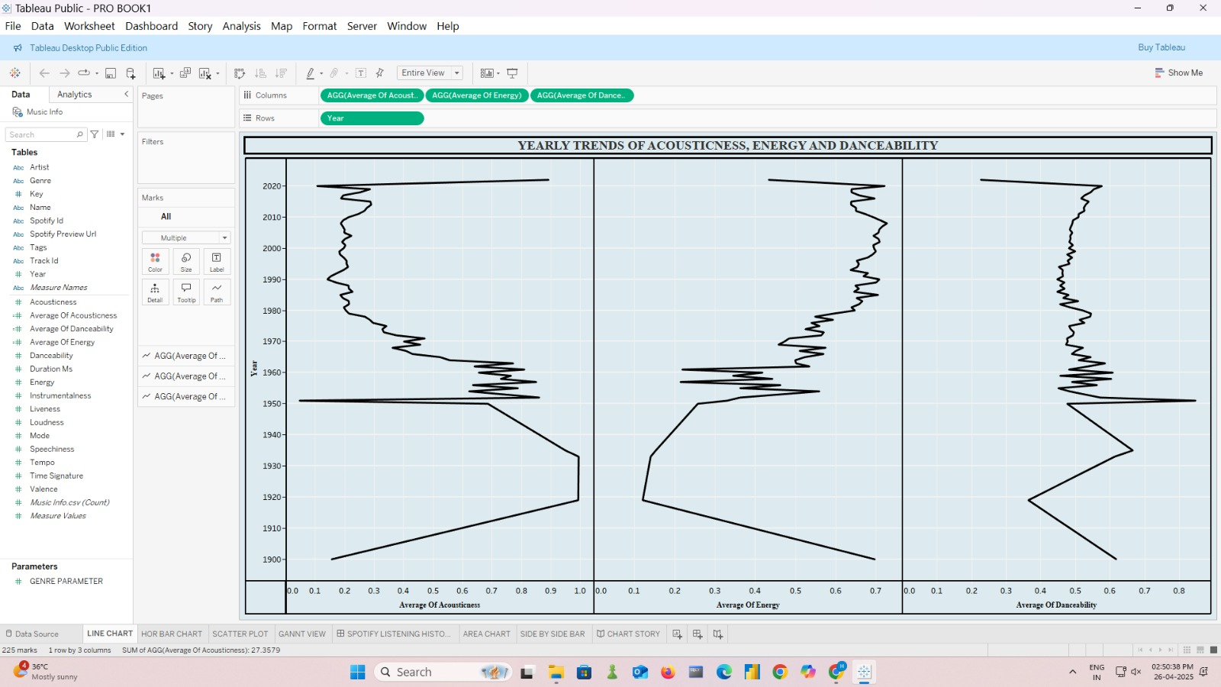

* + Three line graphs plot the trends of Acousticness, Energy, and Danceability from 1900 to 2020.
  + Acousticness measures how acoustic (natural) a track sounds.
  + Energy measures the intensity and activity.
  + Danceability measures how suitable a track is for dancing.

**2. Energy vs Acousticness:**

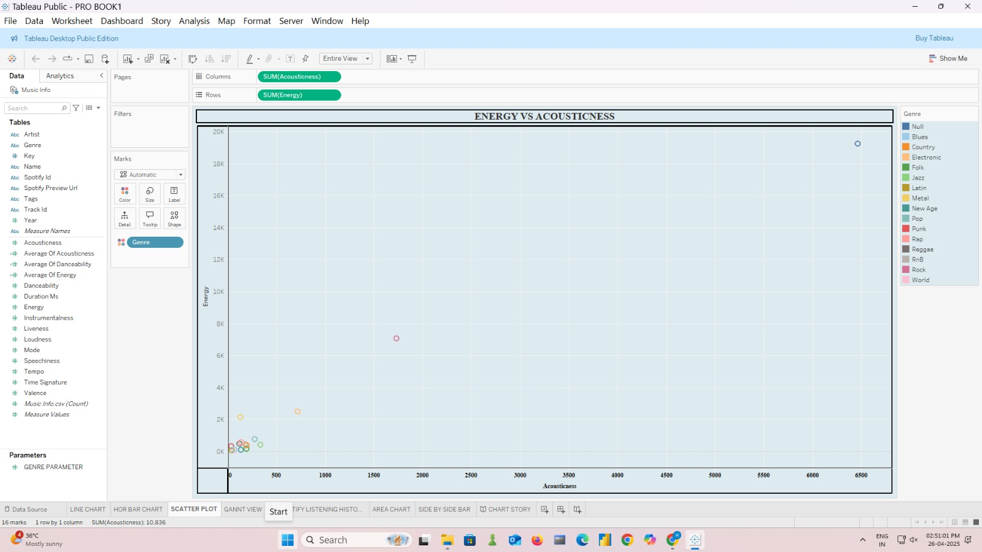

* A two-dimensional scatter plot showing individual tracks based on their Energy (Y-axis) and Acousticness (X-axis).
* Tracks with high energy typically have low acousticness — meaning energetic songs are less natural and more electronically produced.
* Few tracks have both high energy and high acousticness, suggesting that it’s rare for a highly acoustic song to be very energetic.

**3.Year vs Tempo:**

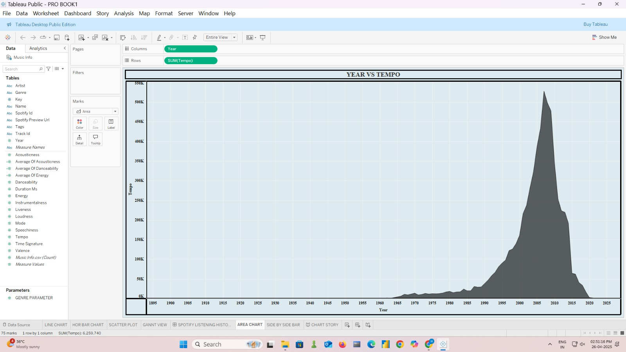

* This chart plots Tempo (speed of a song in beats per minute, BPM) against Year.
* From 1900 to 1950, tempos were moderate (suggesting genres like Jazz, Blues, Classical).
* A sharp increase in tempo after the 1970s aligns with the rise of rock, pop, and disco.
* Post-2000, there’s a broadening in tempo ranges, showing the variety of musical styles — from slow ballads to fast-paced EDM.

**4.** **Genre vs Energy**

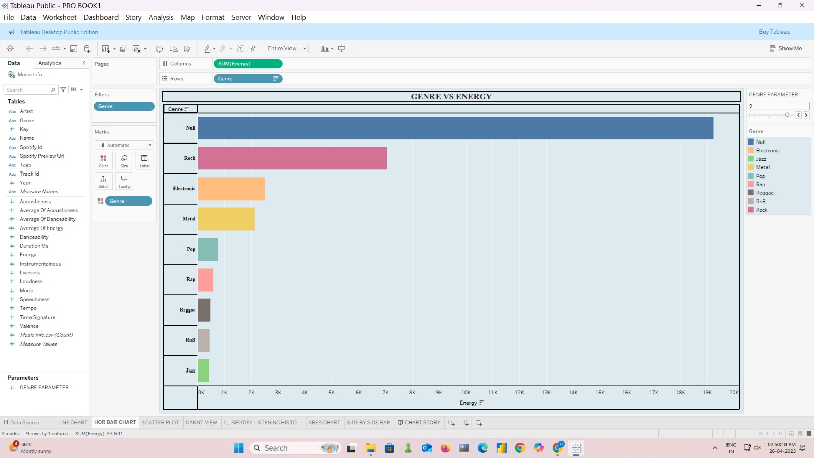

* Displays the average Energy for each Genre.
* Rock and Pop genres exhibit high energy values, which is expected because they focus on electrifying performances.
* Electronic music also shows very high energy, suitable for dance clubs and festivals.
* Jazz and Reggae genres show lower energy, reflecting their more relaxed, laid-back style.

**5. Gantt View of Year and Genre (1900-2020)**

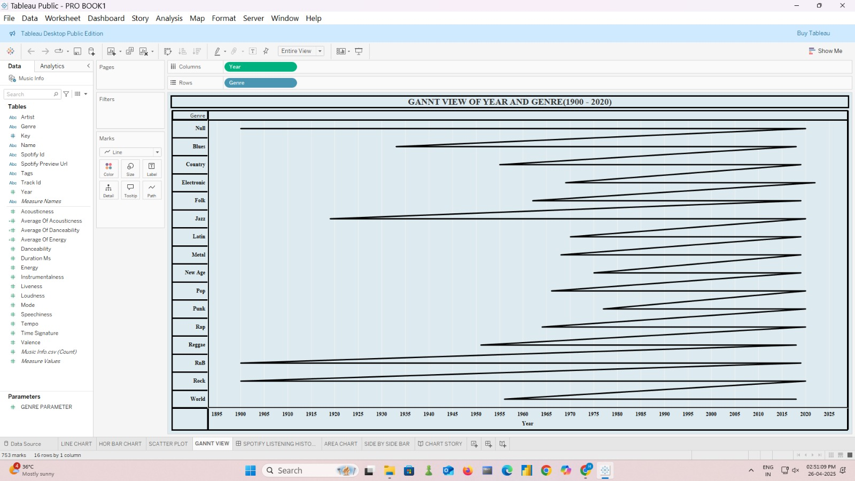

* A time-based chart showing when different Genres were prominent.
* Blues and Jazz appear earlier (before 1950), matching the historical development of modern music.
* Rock and Pop dominate from the 1960s onward.
* Electronic and Hip-hop/Rap genres emerge strongly after the 1980s.

**6. Acousticness vs Energy with Genre:**

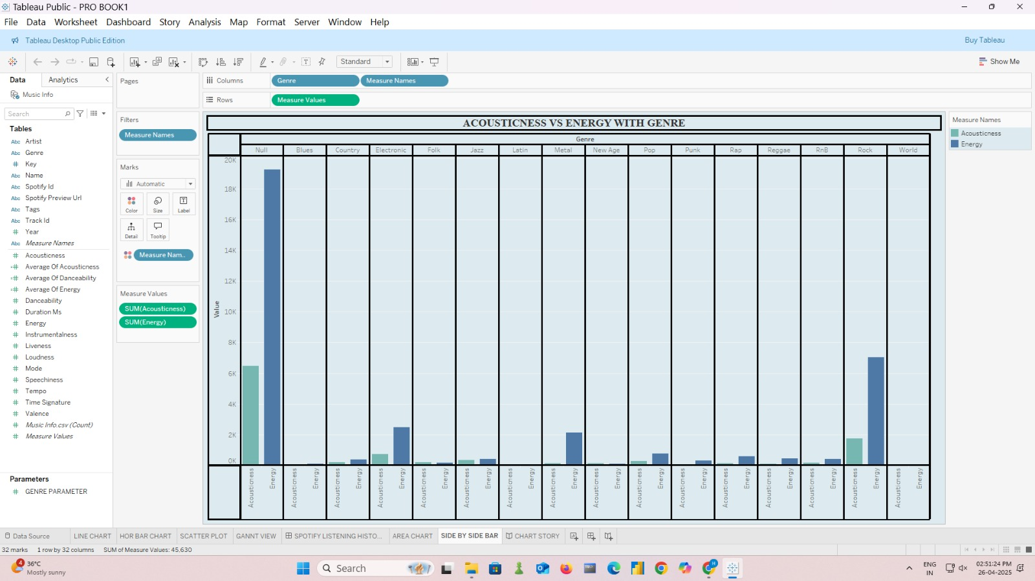

* This compares the Acousticness and Energy for each Genre side-by-side.
* Jazz and Blues have higher acousticness and lower energy, supporting their calm, natural instrumental nature.
* Electronic and Pop have low acousticness and high energy, consistent with heavily produced and synthesized tracks.
* Rock has moderate acousticness but high energy.

**SPOTIFY LISTENING HISTORY DASHBOARD:**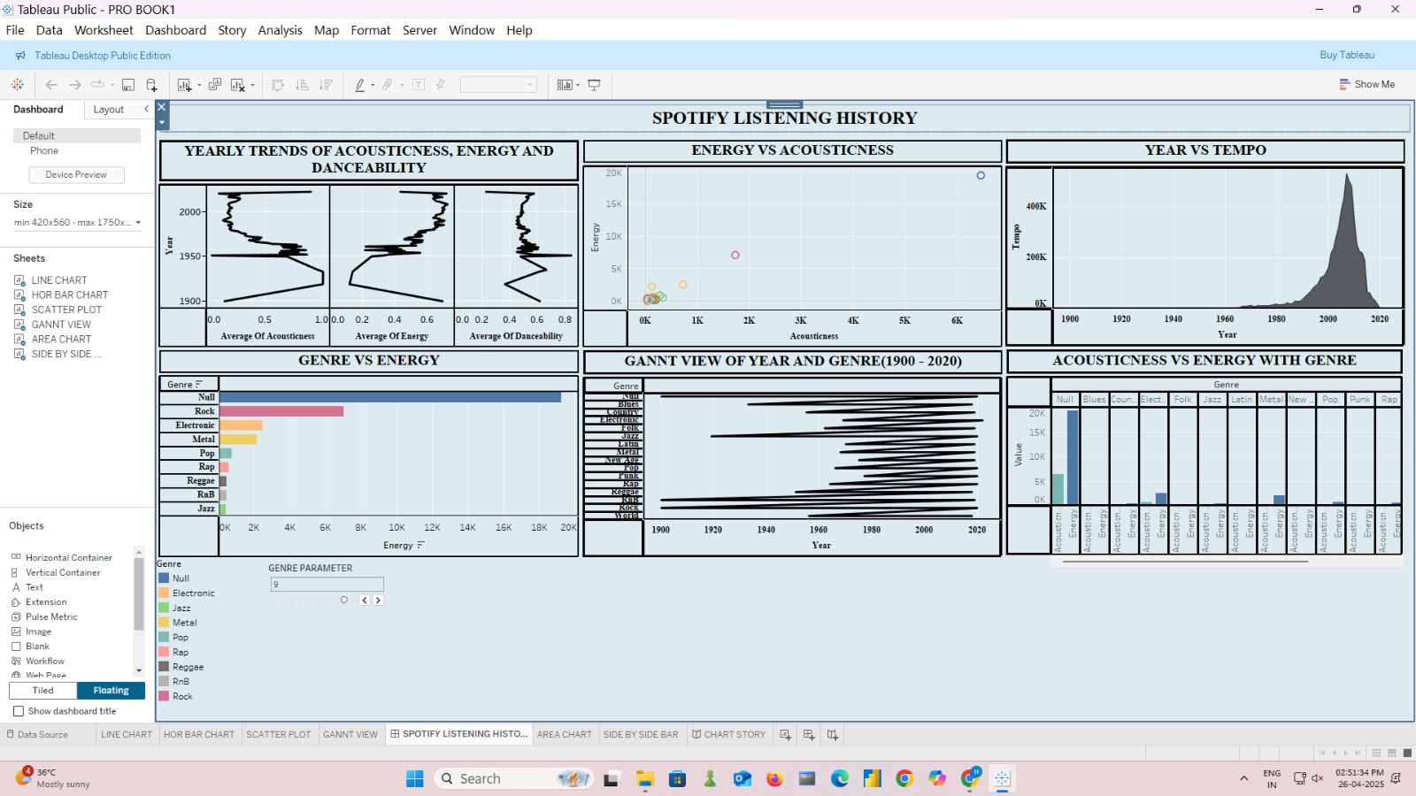

This interactive Tableau dashboard provides a detailed visualization of Spotify listening trends. It explores the yearly trends of acousticness, energy, and danceability from 1900 to 2020. A scatter plot highlights the relationship between energy and acousticness, while an area chart shows how tempo has evolved over the years. The horizontal bar chart presents genre-wise energy distribution, and the Gantt chart gives a timeline of genre popularity across decades. Additionally, a side-by-side bar chart compares acousticness and energy for different genres, offering a comprehensive view of musical preferences and historical shifts.

**SPOTIFY LISTENING HISTORY STORY:**

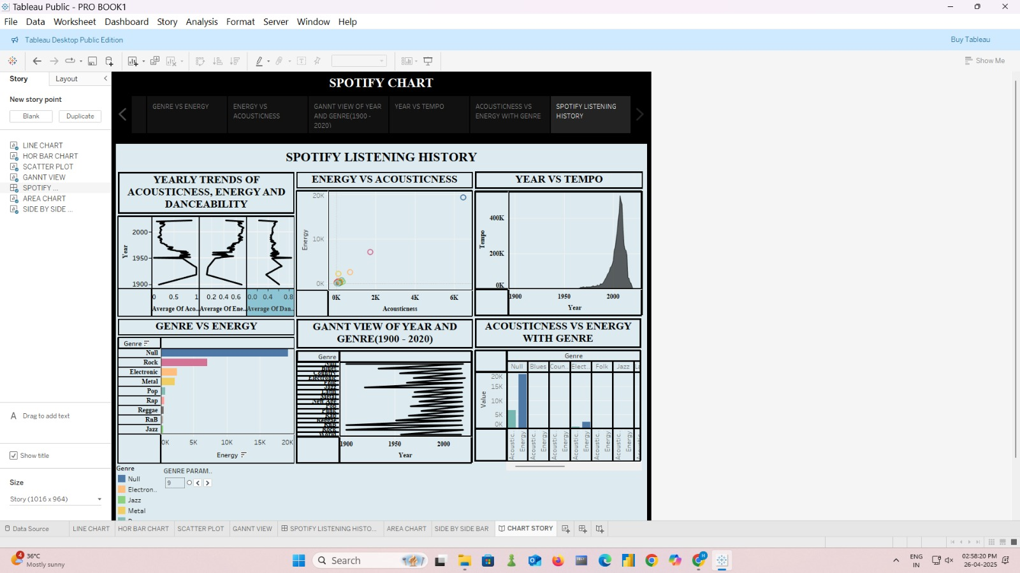

This Tableau Story explores Spotify listening trends across different eras. It highlights how energy, acousticness, and tempo have changed over time, and compares genres based on their musical characteristics. With visualizations like bar charts, scatter plots, and Gantt charts, it gives a clear view of how music styles and preferences evolved from 1900 to 2020.

**Conclusion:**

This Spotify Chart Story provides a clear understanding of how musical elements like energy, acousticness, and tempo have evolved over the decades. It shows that music has become more energetic and dynamic in recent years, with different genres adapting uniquely over time. By analyzing these trends, we can better appreciate the shifting patterns of music preferences and the diversity of listening habits across generations.